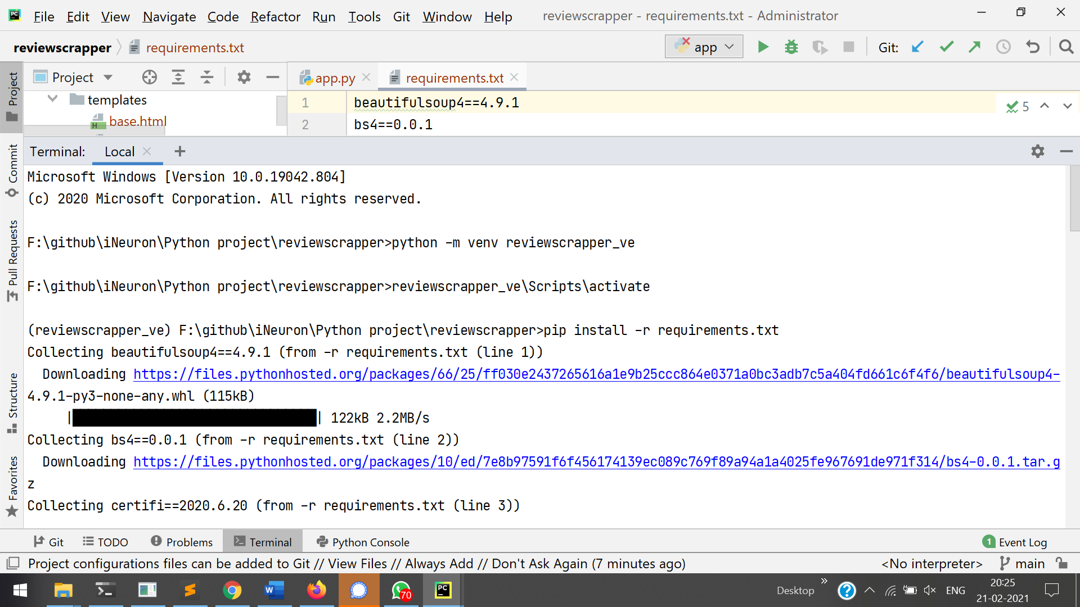

Installing libraries.  
pip install –user -r requirements.txt

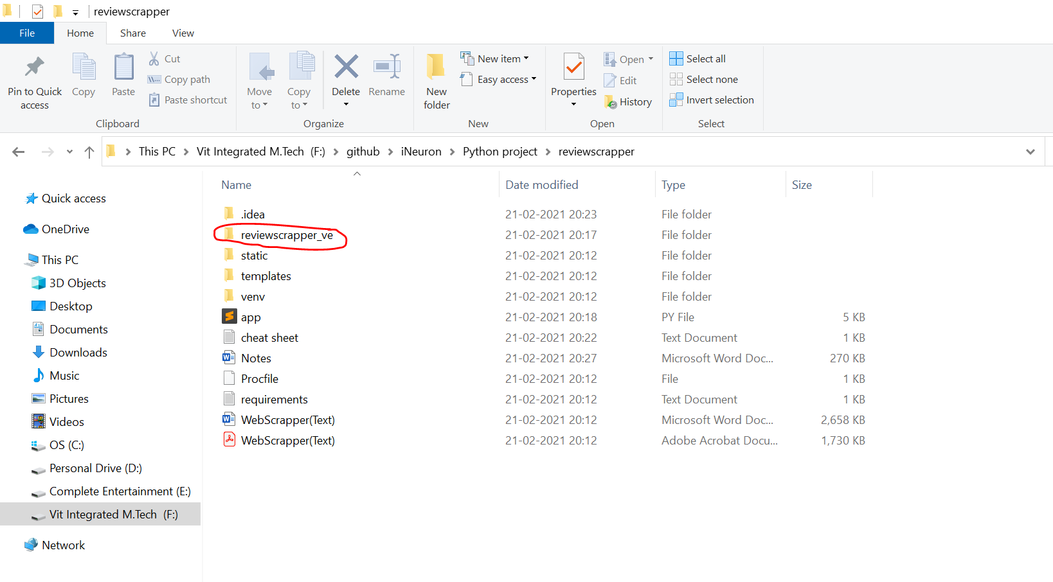

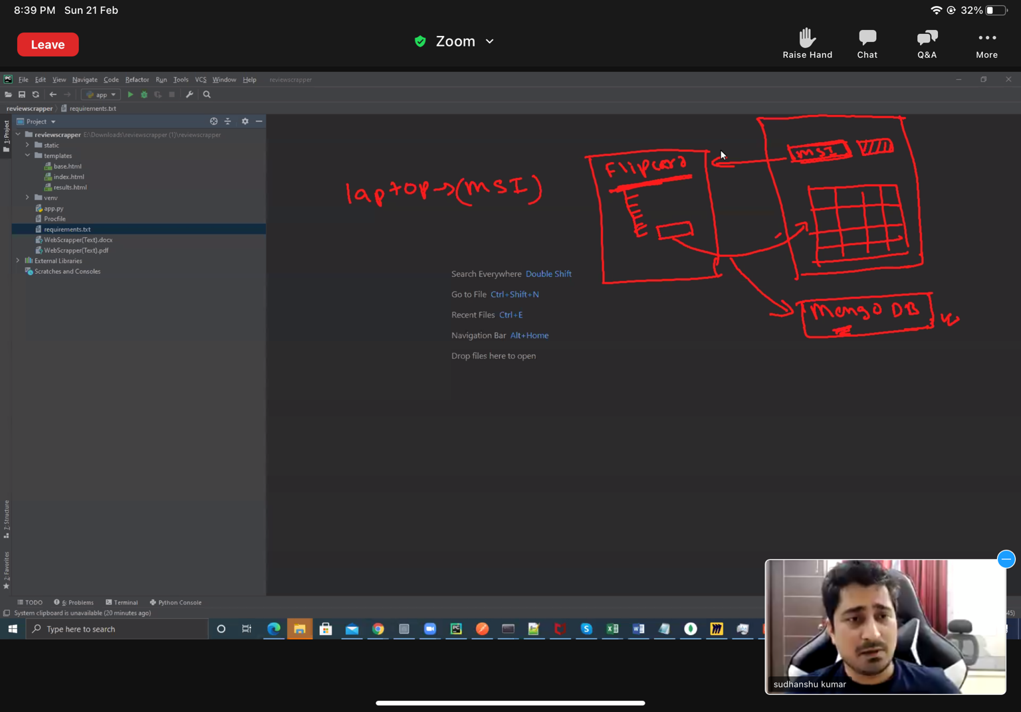

We are going to take only review related data.

3rd party data 🡪 very very important to analyse with our data.  
So only Pipe-lining concept comes into the picture.

Steps  
1. website   
2. Search  
3. Result  
4. info (Selected) Ratings and reviews   
5. Scraping   
6. Done